**_ViewImports.cshtml in ASP.NET Core MVC**

In this short video, we will discuss **_ViewImports.cshtml file in ASP.NET Core MVC**  
  
  
**_ViewImports.cshtml** file is usually placed in the **Views**folder. It is used to include the common namespaces so we do not have to include them in every view that needs those namespaces.    
  
  
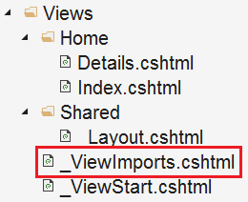   
  
For example, if we include the following 2 namespaces in the **ViewImports** file, then all the types in these 2 namespaces are available to every view in the **"Home"** folder without having to type the fully qualified name of the Type.    
  
@using EmployeeManagement.Models;  
@using EmployeeManagement.ViewModels;   
  
Notice, @using directive is used to include the common namespaces. In addition to @using directive, _ViewImports file also supports the following directives.

@addTagHelper  
@removeTagHelper  
@tagHelperPrefix  
@model  
@inherits  
@inject

**TagHelpers**are new in this version of MVC. We will discuss them in detail in our upcoming videos.   
  
**_ViewImports file is hierarchical**   
  
Just like, _ViewStart file, _ViewImports file is also hierarchical. In addition to placing it in the Views folder, we can also place another _ViewImports in the "Home" sub-folder in the Views folder.    
  
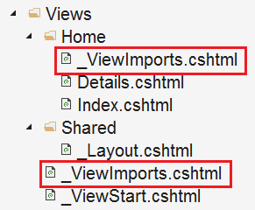   
  
The settings specified in the _ViewImports file in the **Home**sub-folder overwrites the settings specified in the _ViewImports file in the Views folder.    
  
**Please note :**If a setting is specified in the view itself, then that setting overrides the matching settings in the parent _ViewImports files in the folder hierarchy.